ARH 1000 Art Appreciation
Instructor Information
Name: Yarianna Colon-Lopez, M.F.A.
Email: ycolonlopez@valenciacollege.edu
or Directly in Canvas messages box
Office Hours: Virtual appointment, Telephone appointment or scheduled in person
appointments
Credit Hour: 3 credits

Welcome!
I am looking forward to meet you all. I promise you, this class might start as one of those you feel like you only need the credits for and will end up being your favorite! In it you will learn about many art styles and how to appreciate what you see. Art might be something that many overlooks and don’t feel like they need, but with an open heart you will find the magic of Art in this class. You will find yourself finding art everywhere and loving it. Do not hesitate to believe in the power of creativity!
First of all, Who Am I? Who’s your professor?
My name is Yarianna Colon Lopez and I am an artist. I studied Art History and Studio Art because I’m a study-aholic and I needed to know it all. Born and raised in Puerto Rico, moved to Florida almost a decade ago and have taught in multiple Art schools. I love traveling and finding the cemeteries everywhere I go. I also love food, because…food. I’m in love with classical artists and I am kind of a traditionalist when it comes to art styles. I also love teaching and making my class fun to take.

Course description:
This course will provide a foundation for understanding the visual arts. It surveys techniques, vocabulary, art styles and mediums through time. Students will explore a variety of visual experiences and examine two and three-dimensional media. Focus will be placed on The Visual Elements, The Principles of Design and understanding art. There is no prerequisite for this course.

Course objectives:
- Students will gain knowledge of the vocabulary used to describe and critique artworks.
- Students will be able to identify art by regional styles, techniques and aesthetic characteristics.
- Students will learn to understand the importance of art.

Course Format
This course is online and it includes weekly assignments. It is essential to abide by the due dates to be successful in this class.
This course reinforces the following Valencia Student Core Competencies
- Think clearly, critically and creatively by analyzing, synthesizing, integrating and evaluating symbolic works and truth claims.
- Value by understanding your own and others’ values from individual, cultural, and global, perspectives.
- Communicate by reading, writing, and speaking, effectively.
- Act purposefully, reflectively, and responsibly by implementing effective problem solving and decision-making strategies.

Required Materials
Required Text: The following text is required and must be purchased by each student for successful completion of the course:

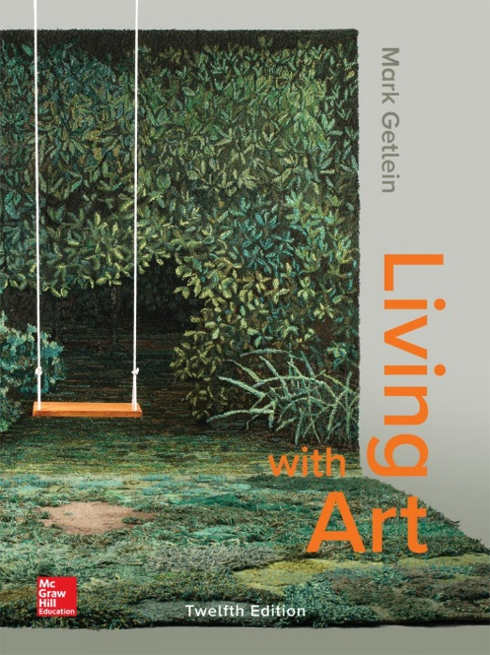
Living With Art by Mark Getlein, 12th edition, ISBN 978-1-259-9167-5 (bound edition)
ISBN 978-1-260-36389-0 (loose leaf edition)
There is a hard cover edition and a loose-leaf edition. There is also a digital version. It does not matter to me which type of book you purchase and use for the class.

Policies concerning test, quiz and assignment deadlines
• Deadline for taking quizzes and tests: Quizzes and tests must be completed by 11:59 pm each Sunday.
• Deadline for submitting homework assignments: Assignment must be completed and submitted by 11:59 pm each Sunday.

Feel like you won’t be able to complete the module on time?
Please, if you are feeling down, sick, you have a trip planned or something happened, contact me as soon as possible. I will give you a chance to complete the module later on but not if you do not contact me on time.
Late homework assignments submitted without an excuse will be docked with a 15%deduction from the original amount of total points available for the assignment.

Gradebook, Guidelines and Grading Criteria for Discussion Boards
Students are required to post to the Discussion Board on a regular basis, as this is the only way to create a "classroom" atmosphere.
• All original threads should contain a minimum of five (5) complete sentences, and must be posted by 11:59 pm on Friday of the week for which it is assigned.
• You should respond to the posts of two other students. These responses should each contain a minimum of three (3) sentences (not counting the greeting) and should be posted by 11:59 pm on Sunday of the week for which it is assigned.
Posts will be graded according to the following criteria:
• Mastery of the subject matter and concepts
• Evidence of strong critical thinking skills through analysis, synthesis, and/or evaluation
• Writing that is clear, edited, articulate, and free of major grammatical errors
• Thoughtful, engaging responses to classmates' posts that enrich the discussion
Attendance and Grading:
The scale is: A=90-100; B=80-89; C=70-79; D=60-69; F=below 60
Attendance is important to successful completion of this class. In an online class, attendance is based on a student's completion of assignments, quizzes, discussion board postings, and tests. A missed deadline for submitting an assignment counts as an absence. After the due date assigned items (whether assignments, discussions, quizzes, or exams) will be closed in the Canvas site and students will no longer be able to access them. If you miss several assignments, these count as absences and you will not have the opportunity to make them up. You will receive a zero on all missing assignments, and those zeros will be calculated into a final letter grade. Students with several missing assignments should consider withdrawing from the class before the withdrawal deadline.
Withdrawal due no show period dates: 10/06- 10/15
Projects
There will be one projects in this class. It is called Creative Projects and will count as a grade.
Your grades will be updated regularly. Consult the Grades area on the left to see your current grade in the course (based on the weightings stated above) and specific grades for assignments. There is also an option in the gradebook to determine what your overall grade will be if you earn certain scores on assignments. Please take advantage of this useful tool.
Class points will be given as followed:

Item | Points
1 Final Test | 200
1 Creative Project | 100
7 Quizzes | 5 each
7 Assignments/Discussions | Points Vary /445 in total
Participation | 20
Total | 770

Academic Honesty:
All students are required to abide by the Academic Honesty Guidelines which have been accepted by the University. For information on what constitutes plagiarism, consult the Student Code of Conduct in the current Valencia Student Handbook.
Students,
Plagiarism is not good. It’s better to hand me a weak writing than a copied one. Effort is valued, plagiarism is dishonest, and it will badly affect your final grade.

For more information, click here Plagiarism
Diversity Statement
I will maintain and recognize the values and dignity of every student. I will encourage inclusion, sensitivity, respect, understanding and tolerance to different believes between students and from myself. A sense of community and a pleasant classroom environment can be reached if everyone follows these standards and focus on bringing our best potential to pursuit the academic goals, while being sensitive human beings.

Students with disabilities:
You must have official documentation from the Office for Student with Disabilities (OSD) and submit it to me at the beginning of the semester in order to help me collaborate with your accommodations. The Office for Students with Disabilities determines accommodations based on appropriate documentation of disabilities. The East Campus office is located in Building 5, Room 216.
For more information, visit Office of Students with Disabilities

Bay Care
Valencia College is interested in making sure all our students have a rewarding and successful college experience. To that purpose, Valencia students can get immediate help with issues dealing with stress, anxiety, depression, adjustment
difficulties, substance abuse, time management, as well as relationship problems dealing with school, home, or work. BayCare Behavioral Health Student Assistance Program (SAP) services are free to all Valencia students and available 24 hours a day by calling (800) 878-5470. Free face-to-face counseling is also available. From college catalog: https://catalog.valenciacollege.edu/studentservices/baycarestudentassistanceservices/

Note to International Students (F-1 or J-1 Visa)
Please be advised that withdrawal from this course due to attendance may result in the termination of your visa status if you fall below the full-time enrollment requirement of 12 credit hours. Contact Valencia’s International Student Services office for more information.

